

MONAGHAN SHOPPING CENTRE
Monaghan, Ireland

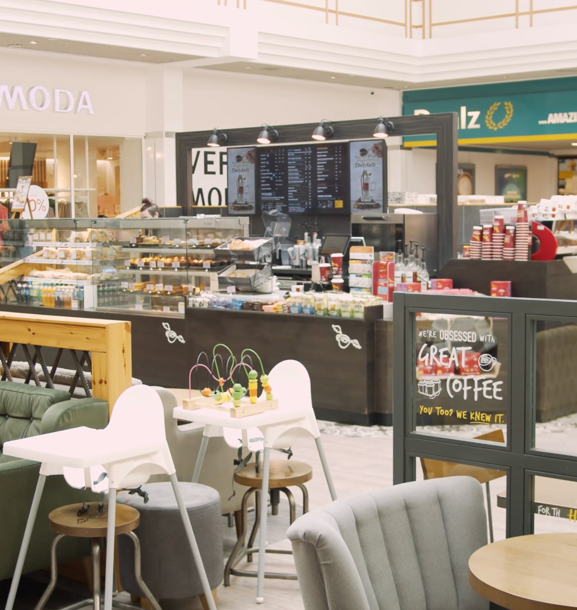

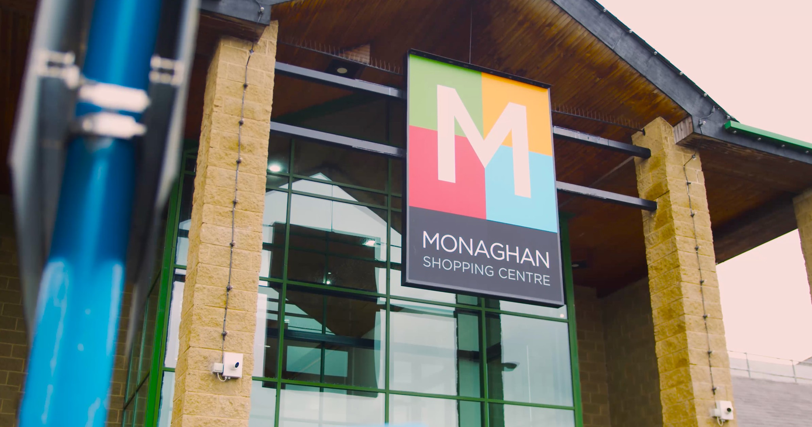
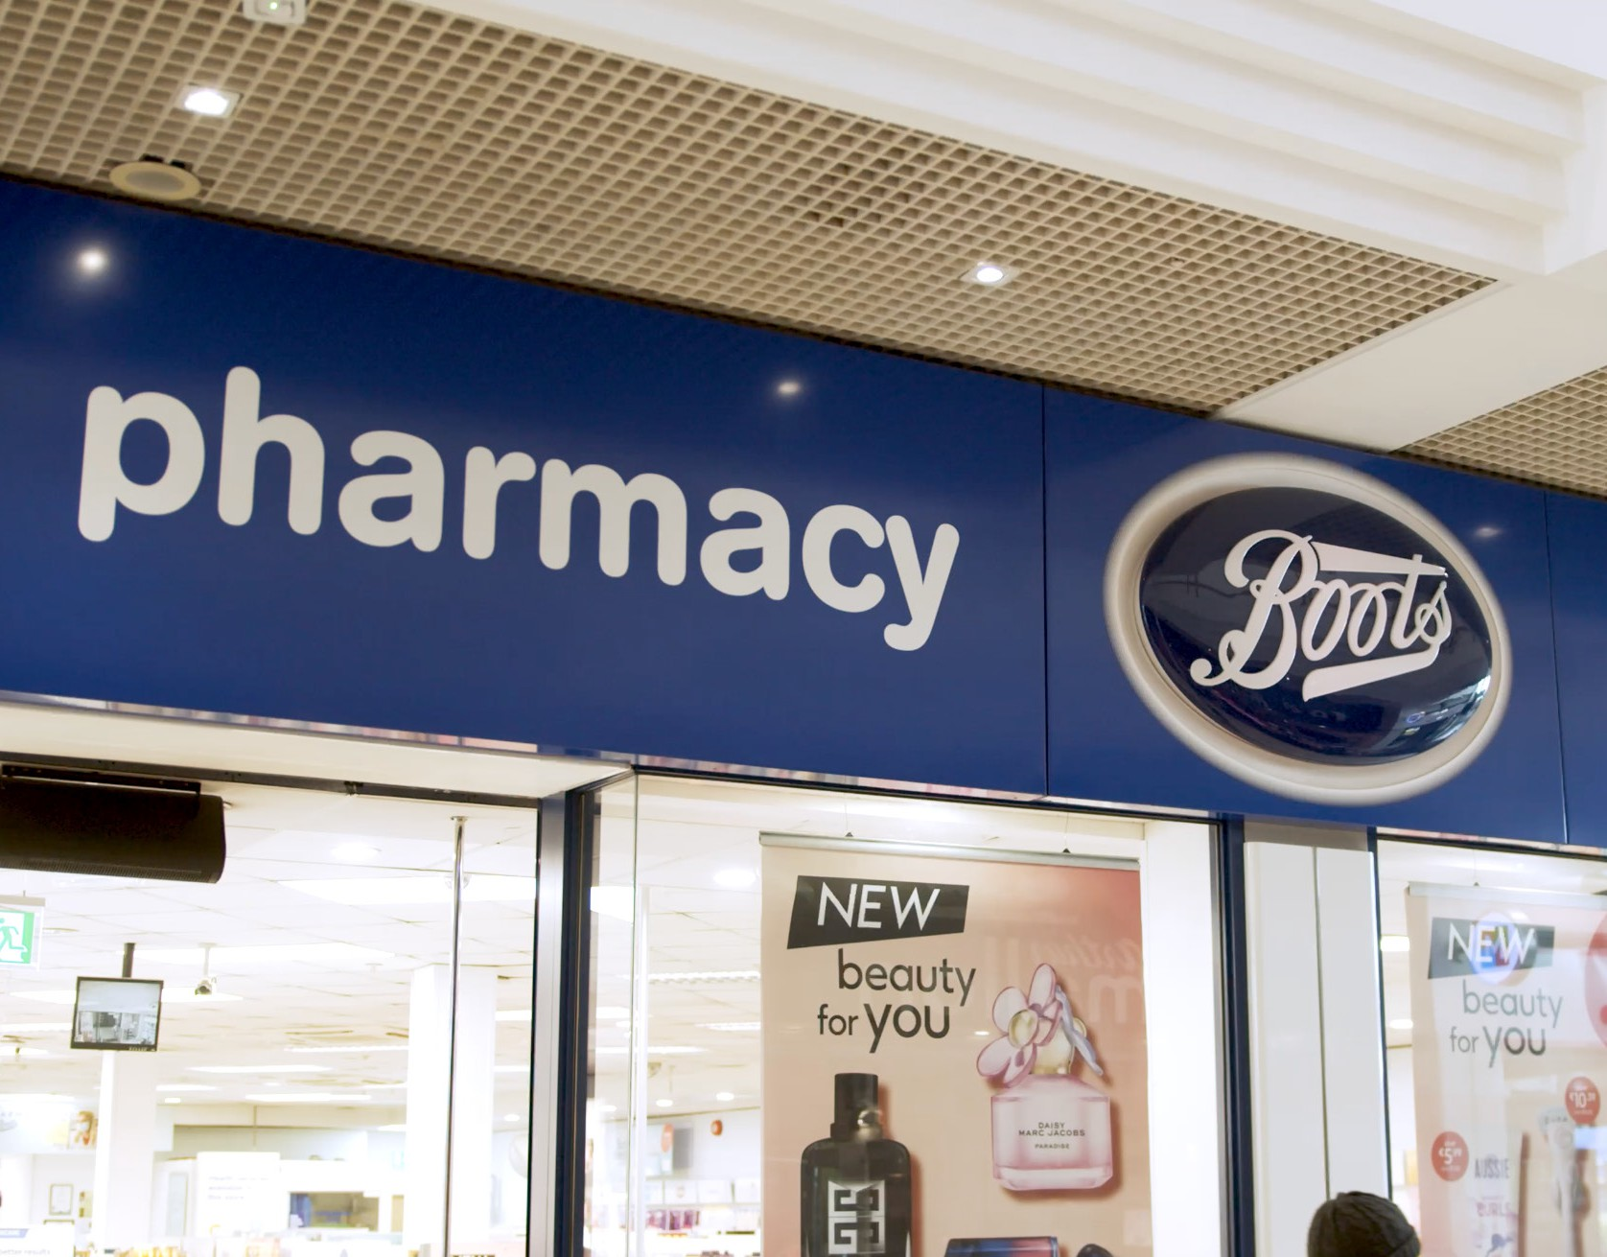
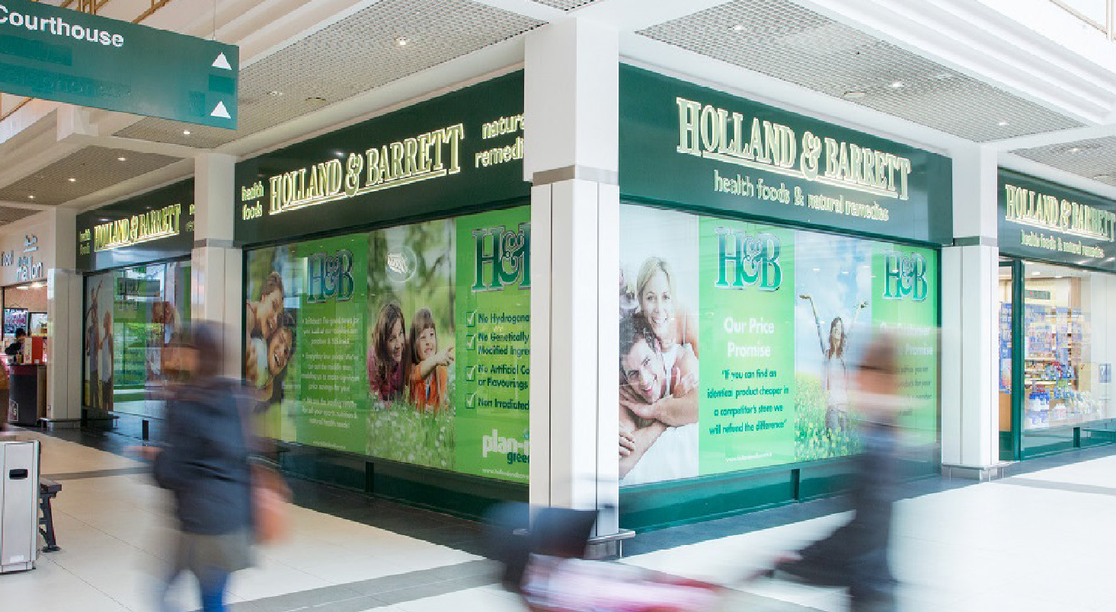
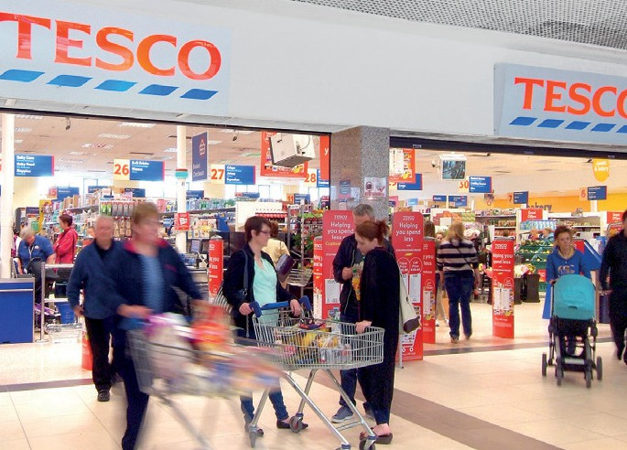
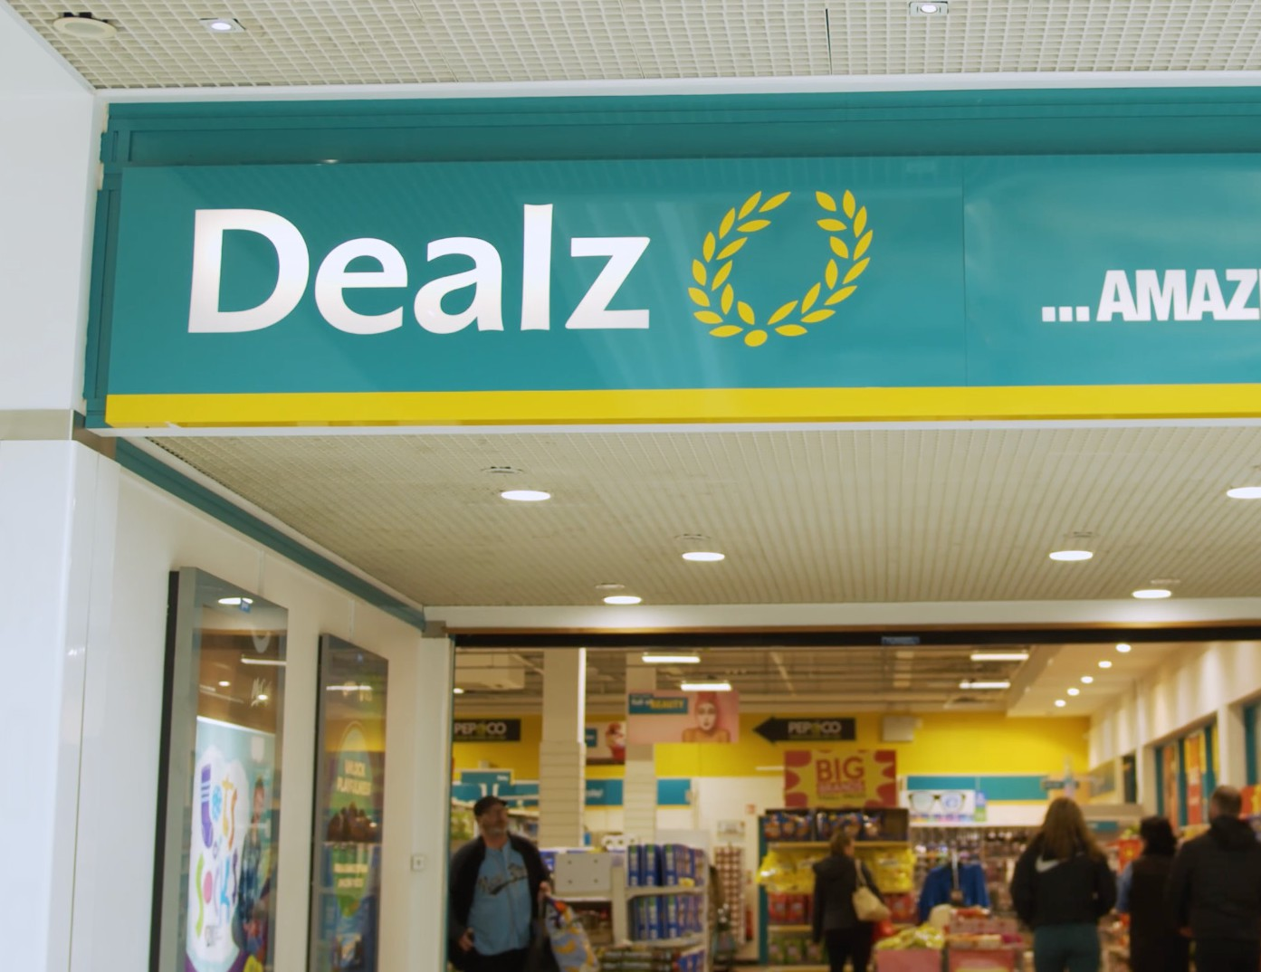
KEY FACTS
- Premier retailing destination in Monaghan
- Over 98,000 sq ft of modern accommodation with ample parking f or customers
- Anchored by a 41,000 sq ft Tesco Supermarket
- Excellent tenant line up including Dealz, Boots, McDonalds, Holland & Barrett, Lifestyle Sports, Insomnia, and Subway
- Average weekly footfall in excess of 47,500 people

MONAGHAN SHOPPING CENTRE 2

Monaghan

Belfast

N2

M1 Dundalk

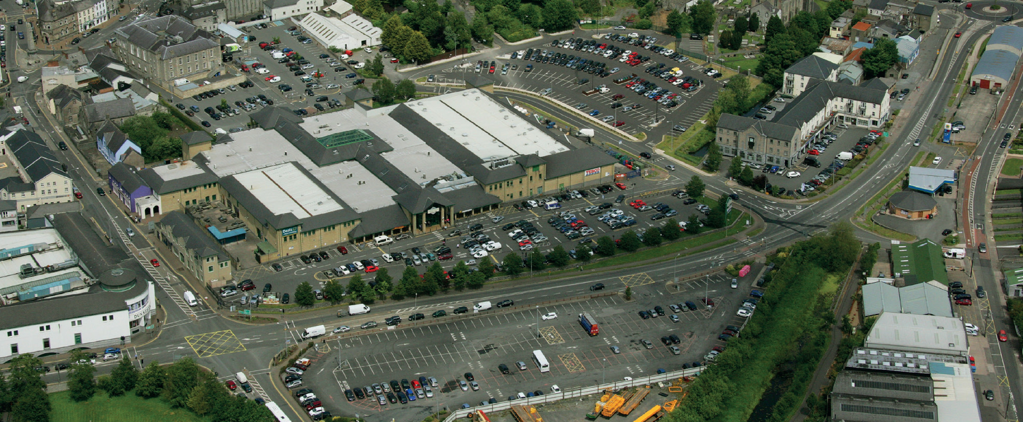
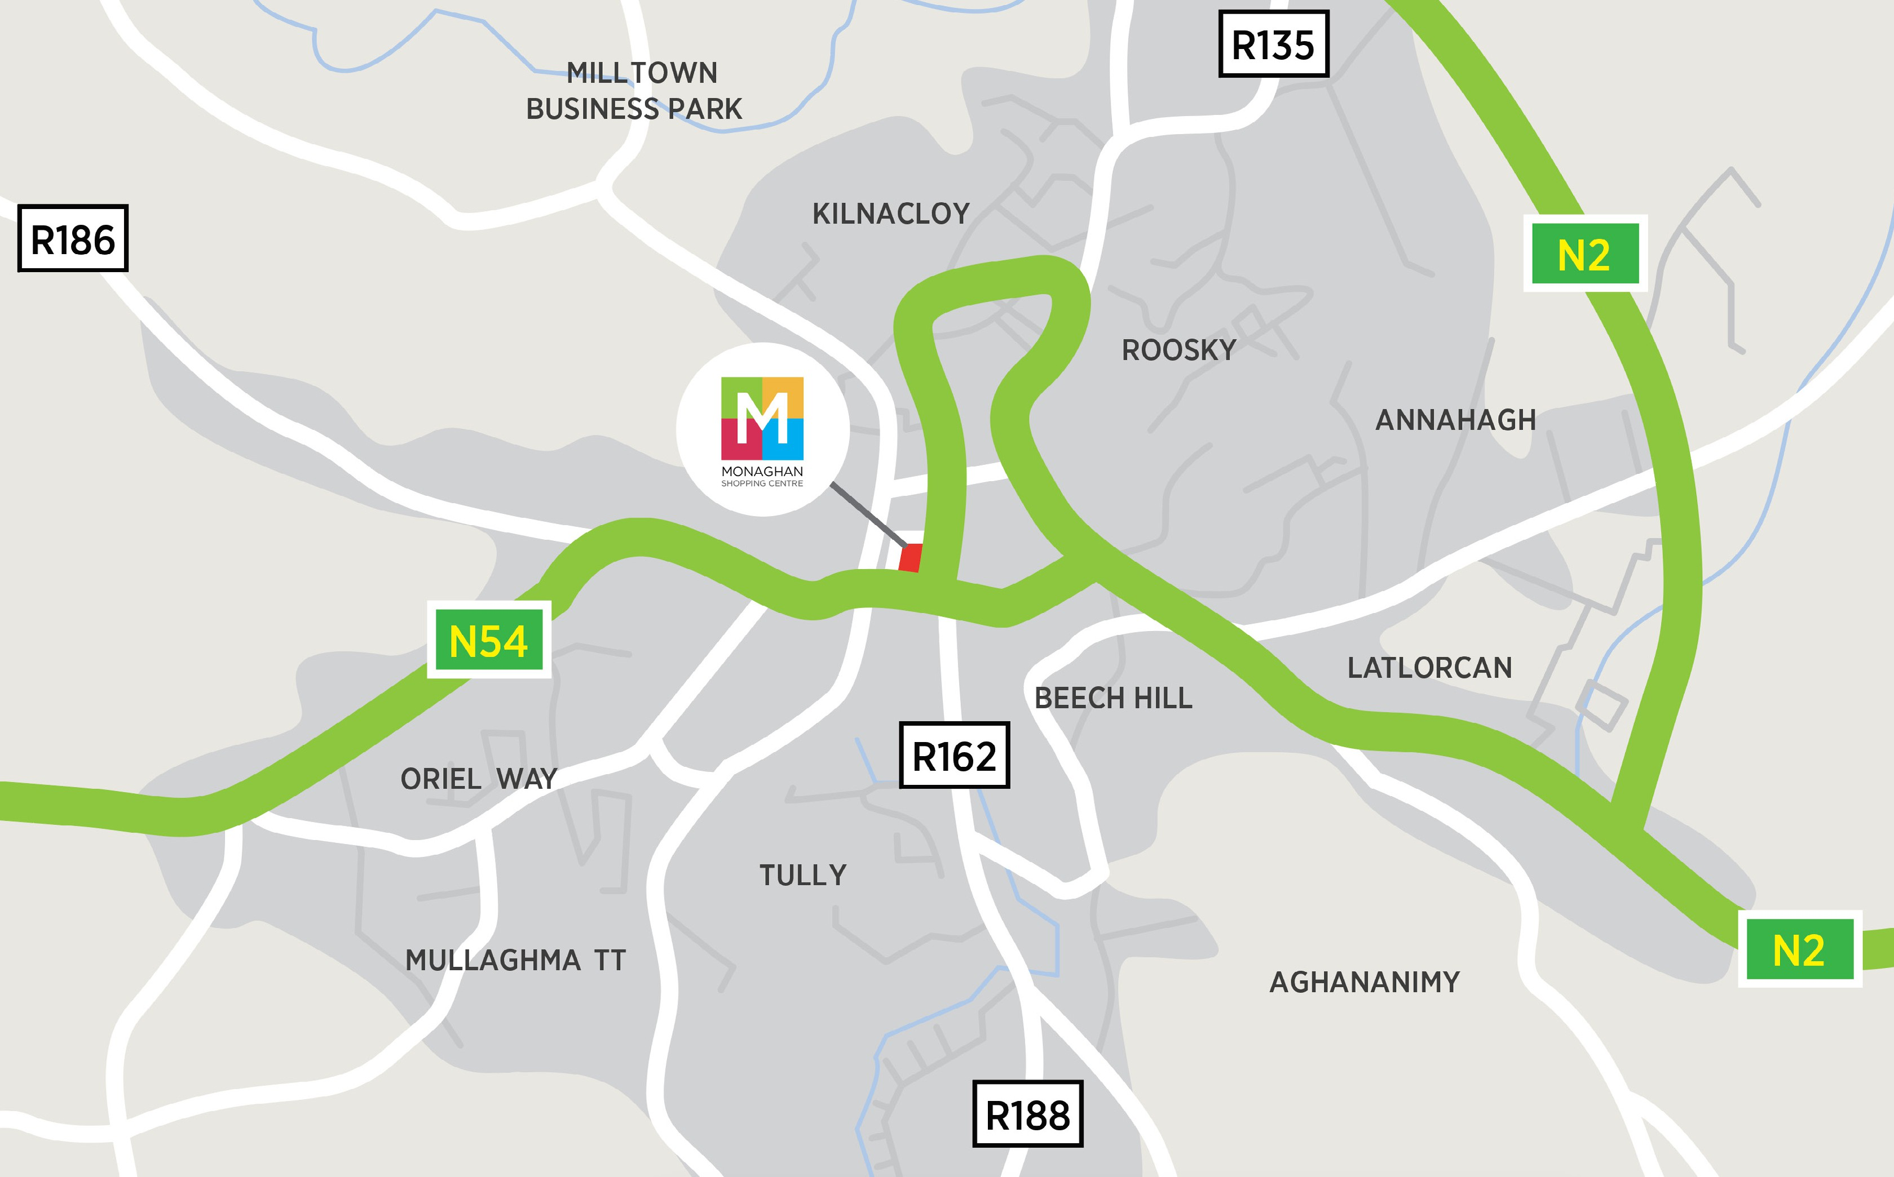
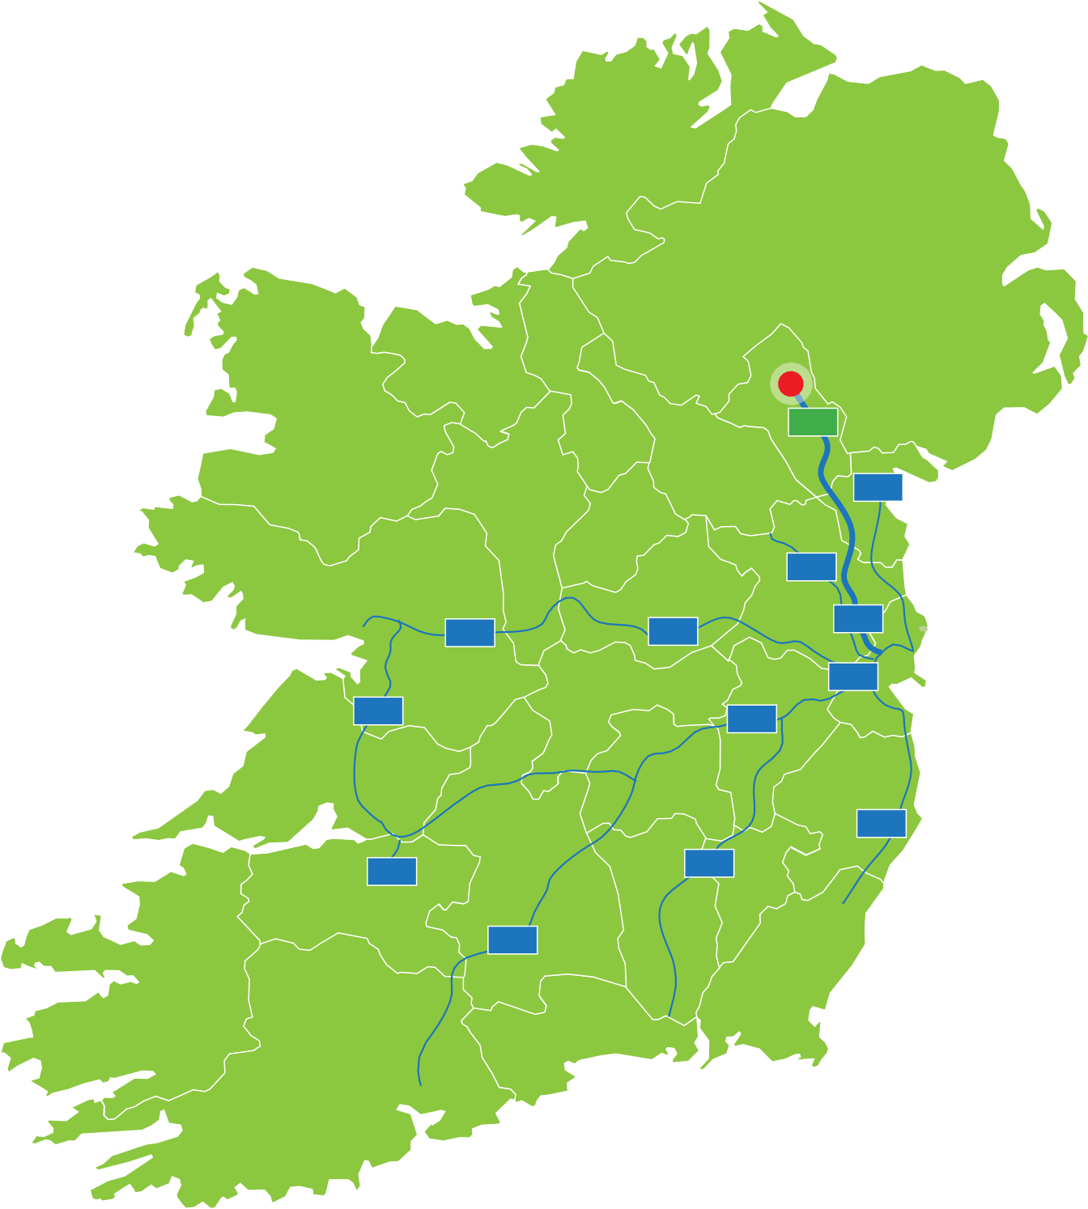
LOCATION
MONAGHAN SHOPPING CENTRE
3
Monaghan Shopping Centre is located in Monaghan Town Centre, the largest urban centre in County
Monaghan acting as the commercial and services centre for the surrounding region.
Monaghan is strategically located at the intersection of the N2 and N54 national primary roads which link with Ireland's extensive motorway network, and the surrounding towns which form Monaghan Shopping Centre's catchment area.

According to the 2022 Census, the population of Monaghan totalled 65,288, an increase of 6 % since the last census.
Monaghan Shopping Centre is a focal point for retailing in Monaghan Town.

Galway
M6

M18

M20

Limerick
M8

Cork
M3

M2
M4

M50

M7

M11

M9

Dublin

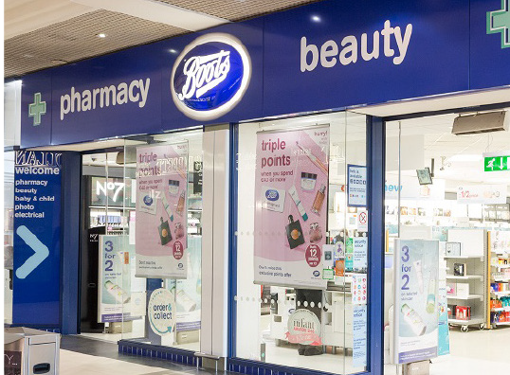
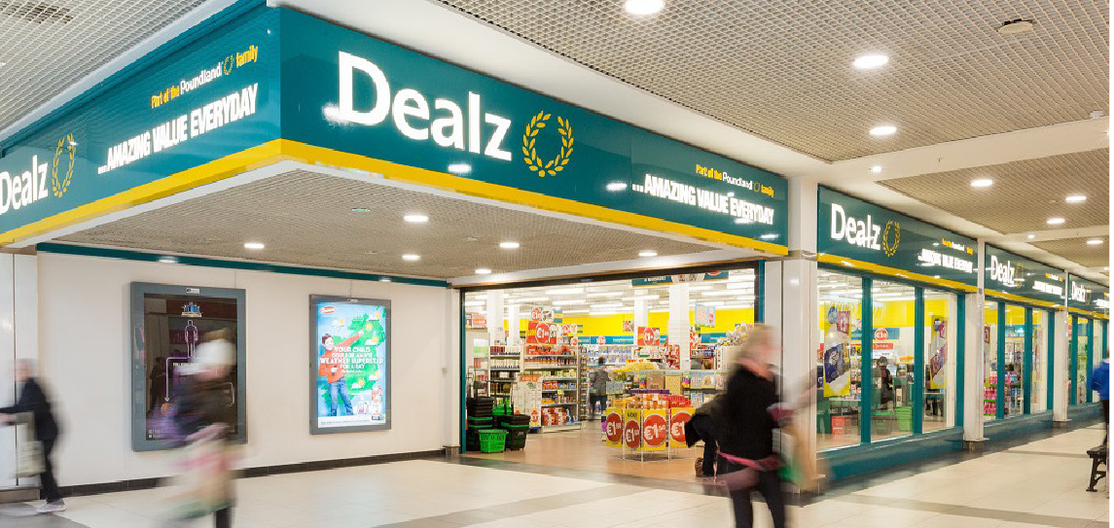
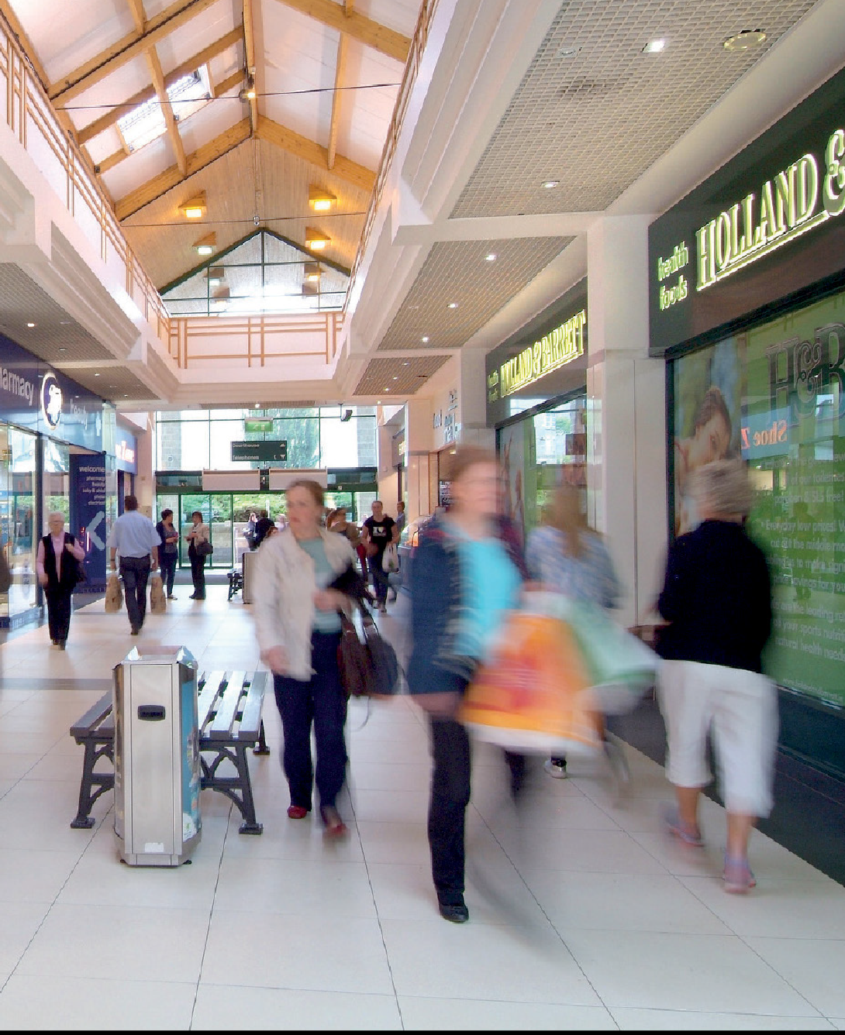
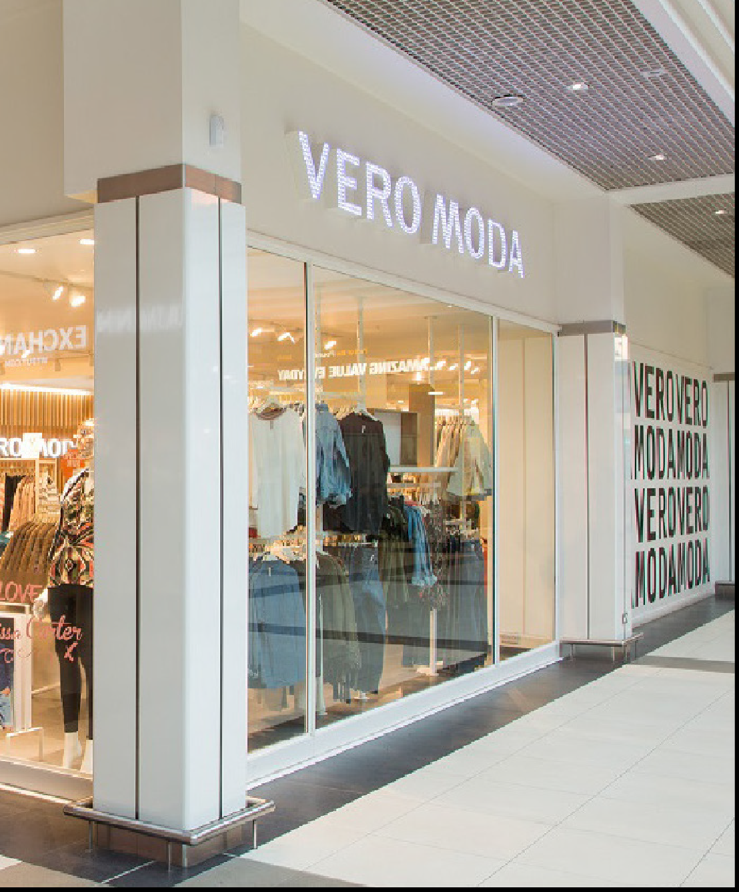
Description
  - Monaghan Shopping Centre comprises a purpose built single level shopping centre which provides the primary shopping offering in Monaghan.
  - The centre comprises c. 9,151.69 sq m (98,508 sq ft) of retail accommodation and is anchored by a 3,804.33 sq m (40,950 sq ft) Tesco supermarket.
  - There are a further 24 well conﬁgured shop units which accommodate an impressive tenant line up. The covered scheme is arranged to provide 3 liner malls each of which has its own entrance and link to a central plaza.
  - Two external car parks provide 182 surface car parking spaces
for customers.

MONAGHAN SHOPPING CENTRE 4
HOUSEHOLDS WITHIN THE CATCHMENT AREA, REPRESENTING AN AVERAGE HOUSEHOLD OF 2.82 PERSONS
18,667

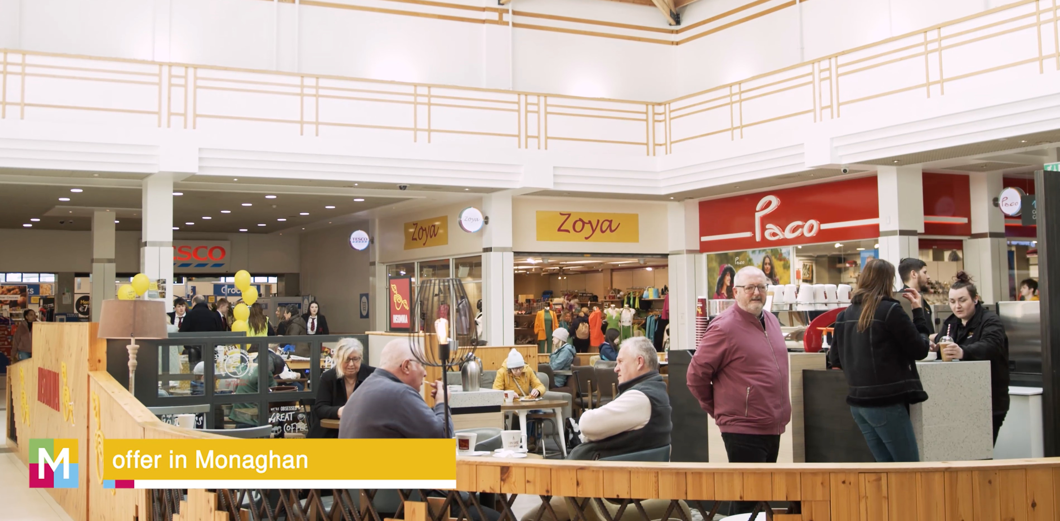

5

MONAGHAN SHOPPING CENTRE

OVERVIEW

Tenant Line up

1
2/3
4
5
6/7
8
Subway Specsavers Moncheri Hugmie Vero Moda Dealz
- AVAILABLE
- AVAILABLE
- Malon's Butcher
18
20/21 Holland & Barrett
- eir
19
- Vodafone
17
24

9/10 Roberto's Gelateria Cafe
- Jack & Jones
- AVAILABLE
- Name It
- Hallmark Cards
15/16 Boots

Available Units
12 785 sq ft + 433 sq ft mezz

17 1,197 sq ft + 711 sq ft mezz

18 1,013 sq ft

26 918q ft + 880 sq ft mezz
- Lifestyle Sports
- Tesco
15/16
22
20/21
23
- AVAILABLE
- Paco
- Bookstation 29/30 AVAILABLE
14
13
26
31/32 McDonalds
4
Roberto’s
Gelateria
9/10
11
12
27
6⁄7
5
28
29/30

















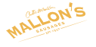











3
2
31/32
25
29-30 2,244 sq ft + 1,005 sq ft mezz
1
8
MONAGHAN SHOPPING CENTRE 6

CONTACT

Paul Kelly
T: (01) 661 1333
E: pkelly@mol.ie
PSR No: 001281 Daniel Cryan
T: (01) 661 1333
E: dcryan@mol.ie

BER certs available upon request.
Conditions to be noted:
- These particulars do not constitute an offer or contract or any part thereof and none of the statements contained in the particulars as to the property to be relied on as a statement or rep-resentation of fact.
- The vendor does not make or give, nor is the Agent(s) or its staff authorised to make or give any representation or warranty in respect to this property.
- All descriptions, dimensions, references to condition and necessary permission for use and occupation, and other details are given in good faith and are believed to be correct but any intending purchaser or tenant should not rely on them as statements or representa-tions of fact but must satisfy himself/herself by inspection or otherwise as to the correctness of each of them.
- In the event of any inconsistency between these particulars and the contract of sale, the latter shall prevail.
- The terms, Vendor and Purchaser, where the context requires shall be deemed to refer to Lessor and Lessee and Landlord and Tenant respectively. 6. Prices are quoted exclusive of VAT (unless otherwise stated) and the purchaser/lessee shall be liable for any VAT arising on the transaction. 7. The Vendor reserves the right not to accept the highest or any offer made.





Find Monaghan Shopping Centre on Facebook & Instagram

